Hand & Brain: The Future of AI-Driven Investing
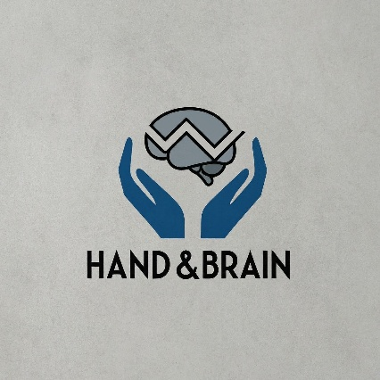
Imagine an investing experience where you don’t need to analyze charts, follow news updates, or manually place trades—yet you still make smart, data-backed investment decisions with minimal risk. Hand & Brain is not just another trading app; it’s a revolutionary AI-powered, fully automated stock trading system that allows individuals to customize their investments while letting AI handle everything—from analysis to execution. Your only task? Enter a PIN to approve trades—AI does the rest.

Why Hand & Brain?
The stock market has traditionally been divided into three extremes:
- High-Frequency Trading (HFTs) – Controlled by elite financial firms, using algorithms to make profits at lightning speed—unavailable to the common investor.
- Mutual Funds – Where investors pool their money, but decisions are made by fund managers with limited personalization.
- Retail Trading – Where the general public buys and sells stocks manually, relying on their own research, emotions, and market knowledge—often leading to inconsistent results.
Hand & Brain bridges this gap—empowering individuals with AI-driven, personalized investment plans that operate with the efficiency of HFTs but are tailored like a smart mutual fund—except you stay in control.

How It Works
- Personalized AI Strategy – Users input their capital, return period, risk appetite, and preferences. AI instantly generates a trading strategy tailored to their goals.
- 360° Market Analysis – The AI evaluates technical indicators, stock charts, and real-time news sentiment to make highly accurate buy/sell decisions.
- Automated Trade Execution – When the AI identifies an opportunity, the user receives a trade suggestion. A single PIN approval executes the trade instantly.
- Full Portfolio Management – The app continuously monitors, rebalances, and optimizes the user’s portfolio based on market conditions.
- Beyond Trading: Education & Insights – Users receive real-time news updates, market education, and portfolio insights to stay informed without the complexity.

Key Benefits
✅ Zero Manual Effort – AI scans the market and executes trades, eliminating emotional and impulsive decisions.
✅ Hyper-Personalization – Unlike mutual funds, your strategy is built for you, not a group of investors.
✅ Minimized Risk, Maximized Returns – AI evaluates all risk factors, ensuring trades have a high success probability.
✅ Complete Autonomy – Unlike HFT firms or fund managers, you remain in control with just a PIN approval.
✅ Standalone System – No dependency on third-party brokerage platforms, ensuring better execution and security.

The Future of Investing is Here
Hand & Brain is not just an app—it’s a revolution. It transforms stock trading from a complex, time-consuming task into an effortless, AI-driven wealth-building experience. No more guesswork. No more uncertainty. Just smart, automated, and efficient investing at your fingertips.
Are you ready to invest smarter? Hand & Brain is the future.

